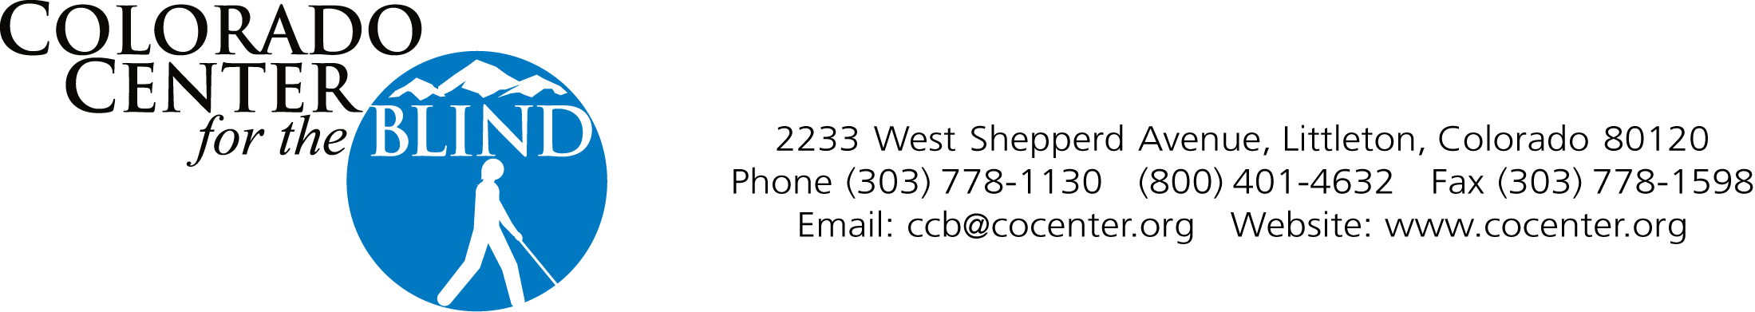

APPLICATION
2018 Confidence Camp for Kids Elementary Program
For ages 5-11

Note: Applications will be reviewed based on the order received.

Date: __________________

Child’s Name__________________________________________________________
Date of Birth ___________________________________________________________
Male___________ Female___________
Home Address__________________________________________________________
City _________________________________ State ____________ Zip Code _______

Father's or Guardian's Name _________________________________________________
Home Address ____________________________________________________________
City ____________________________ State ______________ Zip Code _____________
Home Phone ___________________________ Cell Phone _________________________
Email ______________________________________
Is this person approved to pick up student from the program? ____________

Mother's or Guardian's Name __________________________________________________
Home Address ______________________________________________________________
City____________________________ State _______________ Zip Code ______________
Home Phone ___________________________ Cell Phone __________________________
Email _______________________________________
Is this person approved to pick up student from the program? ____________

Other persons approved to pick up student from the program: ________________________
______________________________________________________________________________

Who can we contact if we can't reach you in an emergency?
Name ________________________________________________________________________
Home Phone __________________________ Cell Phone_________________________
Email __________________________________
Relation ____________________________________________________________________

Name of TVI___________________________________
Phone________________________________________
Email__________________________________________

Method used to study and take notes in school:
Braille _____ Large Print _____ Standard Print _____ Note taker_____
Other (please explain) ________________________________________

Method used to travel in school and in public:
Long White Cane ________ Sighted guide_______ None ______
Other (please indicate) ___________

Health Statement
Please attach a copy of child’s immunization record and medical insurance card.
In order for our staff to better understand your child, please complete the following medical information. Note there are no medical professionals on site at the Colorado Center for the Blind.

Child’s name: _________________________________________________________________
Date of last visit to physician or health exam: _______________________________________
Past history of serious injuries or illnesses: _________________________________________
_____________________________________________________________________________
Cause of blindness: ____________________________________________________________
Secondary disabilities: ______________________________________________________________
Allergies: ___________________________________________________________________
Allergic reactions: ____________________________________________________________
______________________________________________________________________________
Special dietary requirements: ________________________________________________
______________________________________________________________________________
Any information that will help us in working with your child: _______________________________
______________________________________________________________________________
______________________________________________________________________________
______________________________________________________________________________
Doctor’s Name ________________________________________________________________
Address _______________________________ Phone ________________________________
City _____________________________ State ______________ Zip Code _____________

Medications currently being used:

- Name of medication: ___________________________________________________________
Medication is used for: ______________________________________________________
Date prescribed: _____________________________________________________________
Directions for usage: ________________________________________________________
- Name of medication: ___________________________________________________________
Medication is used for: _______________________________________________________
Date prescribed: ______________________________________________________________
Directions for usage: _________________________________________________________

Colorado Center for the Blind
Authorization for Emergency Medical Care

I hereby give my permission to the Colorado Center for the Blind officials to call a doctor or emergency medical service and for the doctor, hospital, or medical service to provide emergency medical or surgical care for (child’s name) ___________________________________________
should an emergency arise. It is understood that the Center officials will make a conscientious effort to locate the emergency contacts listed on the document before any action will be taken. If it is not possible to locate emergency contacts listed, I accept the expense of emergency medical or surgical treatment.

_____________________________________________________________
Parent Name

_______________________________________________________________
Parent Signature

______________________________________
Date

Colorado Center for the Blind
Authorization to participate in the Colorado Center for the Blind Program Activities:

I hereby give permission for (child’s name) _________________________________ to go on trips away from the Center's premises, whether on foot or by vehicle, and to participate in all Center activities.

_______________________________________________________________
Parent Name

_____________________________________________________________
Parent Signature

______________________________________
Date

Colorado Center for the Blind
National Federation of the Blind

Media/Social Media Release Effective 3/1/16

- I understand that I may be photographed, videotaped, recorded and/or interviewed for print, online or other distribution while a student/participant at the Colorado Center for the Blind.
- I grant permission to the Colorado Center for the Blind to allow said video, photo, audio, film likeness or interview to be used or released to others for any legitimate purpose by the Colorado Center for the Blind or National Federation of the Blind.
- I further grant permission for my image to be posted to social media such as Face Book, Twitter and others that may be used by the Colorado Center for the Blind and the National Federation of the Blind.

If Participant is 18 years of age or older:

_____ No, I do not grant permission for my image, likeness or voice to be shared.

_____ Yes, I give permission to the Colorado Center for the Blind and the National Federation of the Blind to use media containing my image, recorded voice, etc. as detailed above.

Participant Name (Please print): ______________________________________

Participant Signature: _______________________________________________

Date: _____________ Phone: __________________________ Email: __________________________

If Participant is under age 18:

_____ No, I do not grant permission for my image, likeness or voice or my child’s image, likeness or voice to be shared.

Yes, I give permission to the Colorado Center for the Blind and the National Federation of the Blind to use media containing (please check all that apply):

_______My image, recorded voice, etc. as detailed above and/or

_______My child’s image, recorded voice, etc. as detailed above

Child’s name _______________________________________

Parent/Guardian Name: ______________________________

Parent/Guardian Signature: ____________________________

Date: ____________ Phone: __________________________ Email: __________________________

